Internal Job Portal
Objective:
Internal Job Portal is an online application to be built as a product that can provide a one-stop point for all employees to apply/view job postings, comment on postings, post job requirements etc..

Users of the System:
- Admin
- HR
- Employees

Functional Requirements:
- The System should enable Project Managers to submit their job requirements to the HR for posting.
- System should incorporate an approval cycle where the HR validates the submitted job posting before posting to the portal
- System should enable employees to view and apply different jobs, allow discussions about jobs etc..
- System should enable Project Managers to View their Job Postings, Applicant details and their profiles for a particular Job Posting.

While the above ones are the basic functional features expected, the below ones can be nice to have add-on features:
- Filters for products like Low to High or showcasing products based on the customer’s price range, specific brands etc.
- Email integration for intimating new personalized offers to customers.
- Multi-factor authentication for the sign-in process
- Payment Gateway

Output/ Post Condition:
- Records Persisted in Success & Failure Collections
- Standalone application / Deployed in an app Container

Non-Functional Requirements:

Security | - App Platform –UserName/Password-Based Credentials  - Sensitive data has to be categorized and stored in a secure manner  - Secure connection for transmission of any data
Performance | - Peak Load Performance  - Job portal -< 3 Sec  - Admin application < 2 Sec
Availability | - 99.99 % Availability
Standard Features | - Scalability  - Maintainability  - Usability  - Availability  - Failover
Logging & Auditing | - The system should support logging(app/web/DB) & auditing at all levels
Monitoring | - Should be able to monitor via as-is enterprise monitoring tools
Cloud | - The Solution should be made Cloud-ready and should have a minimum impact when moving away to Cloud infrastructure
Browser Compatible | - IE 7+  - Mozilla Firefox Latest – 15  - Google Chrome Latest – 20  - Mobile Ready

Technology Stack
Front End | Angular 7+  Google Material Design  Bootstrap / Bulma
Server Side | Spring Boot  Spring Web (Rest Controller)  Spring Security  Spring AOP  Spring Hibernate
Core Platform | OpenJDK 11
Database | MySQL or H2

Platform Pre-requisites (Do’s and Don’ts):
- The angular app should run in port 8081. Do not run the angular app in the port: 4200.
- Spring boot app should run in port 8080.

Key points to remember:
- The id (for frontend) and attributes(backend) mentioned in the SRS should not be modified at any cost. Failing to do may fail test cases.
- Remember to check the screenshots provided with the SRS. Strictly adhere to id mapping and attribute mapping. Failing to do may fail test cases.
- Strictly adhere to the proper project scaffolding (Folder structure), coding conventions, method definitions and return types.
- Adhere strictly to the endpoints given below.

Application assumptions:
- The login page should be the first page rendered when the application loads.
- Manual routing should be restricted by using AuthGaurd by implementing the canActivate interface. For example, if the user enters as http://localhost:4200/signup or http://localhost:4200/home the page should not navigate to the corresponding page instead it should redirect to the login page.
- Unless logged into the system, the user cannot navigate to any other pages.
- Logging out must again redirect to the login page.
- To navigate to the admin side, you can store a user type as admin in the database with a username and password as admin.
- Use admin/admin as the username and password to navigate to the admin dashboard.

Validations:
- Basic email validation should be performed.
- Basic mobile validation should be performed.
Project Tasks:
API Endpoints:
USER
Action | URL | Method | Response
Login | /login | POST | true/false
Get All Job Post – Home | /home | GET | Array of Job Post
Add to Applied Job | /home/{id} | POST | Job aApplied
All Applied Jobs | /appliedJobs/{id} | GET | Array of AppliedJobs
Delete Applied Jobs | / appliedJobs /delete | Delete | Applied Job Deleted
HR
Action | URL | Method | Response
Get All Jobs | /hr | GET | Array of Jobs
Add Job | /hr/addJob | POST | Job added
Delete Job | /hr/delete/{id} | GET | Job deleted
Job Edit | /hr/jobEdit/{id} | GET | Get All details of Particular id
Job Edit | /hr/jobEdit/{id} | PUT | Save the Changes
Get All AppliedJobs | /hr/allAppliedJobs | GET | Array of AppliedJobs
ADMIN
Add HR | /admin/add | POST | HR added
Update HR | /admin/update/{id} | PUT | HR Updated
Delete HR | /admin/delete/{id} | DELETE | HR deleted
Get All HR | /admin/ | GET | Return array of HR
Frontend:
Employee:
Login:
Output Screenshot:
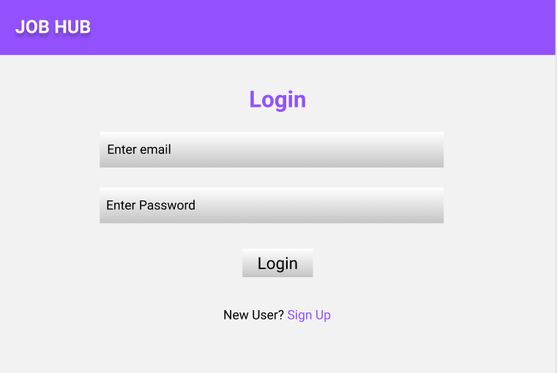
Signup:
Output Screenshot:
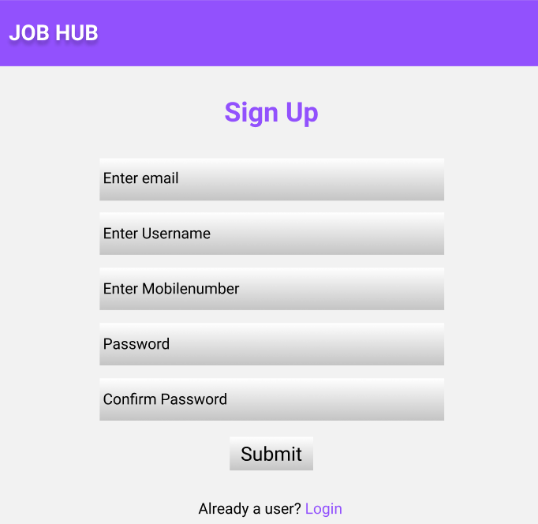
Home:
Output Screenshot:
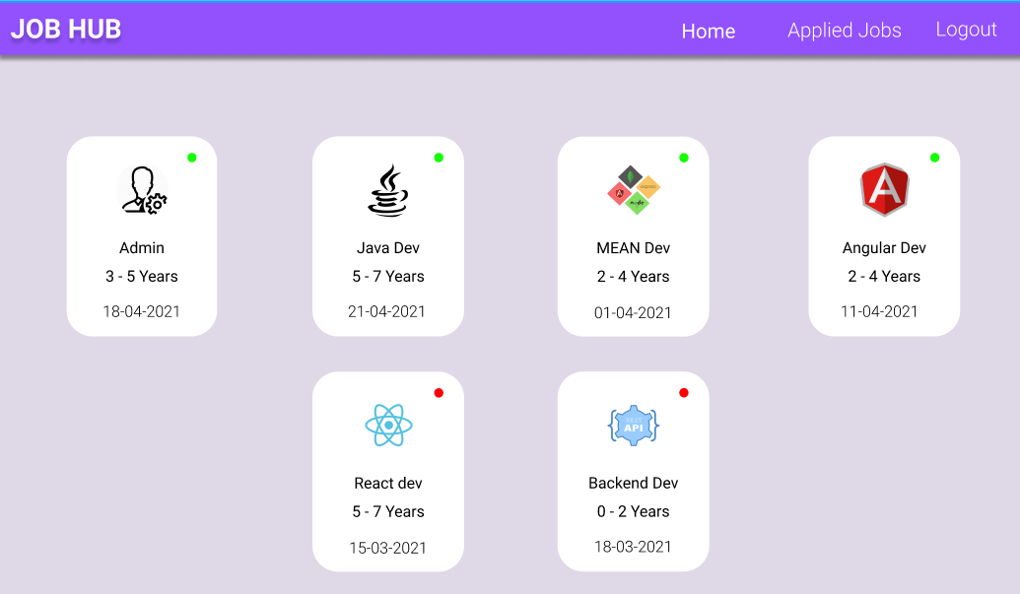
Apply:
Output Screenshot:
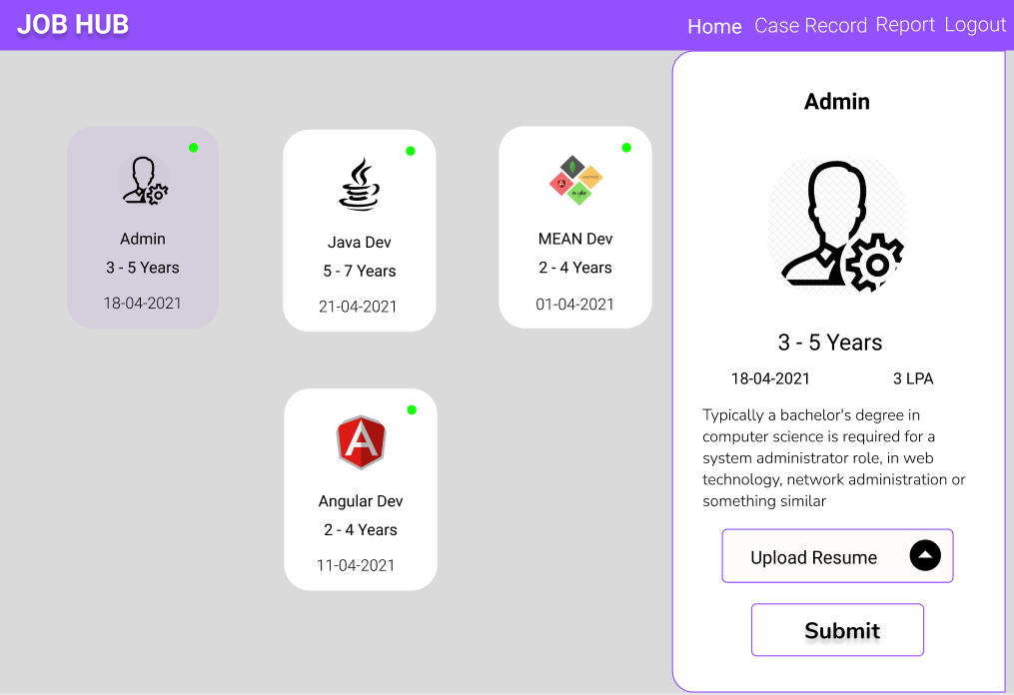
Applied Jobs:
Output Screenshot:
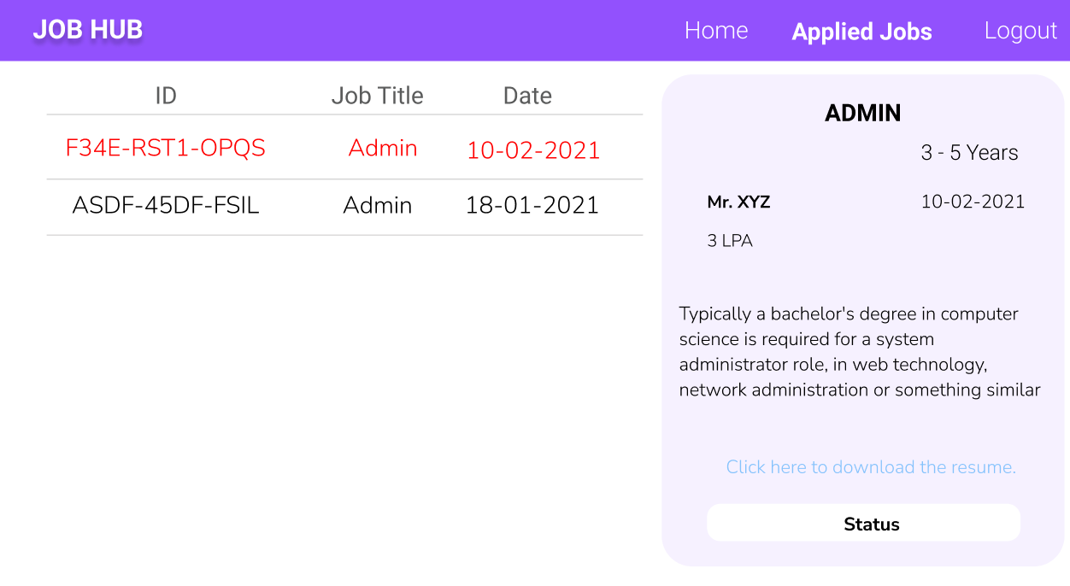

HR:
Home:
Output Screenshot:
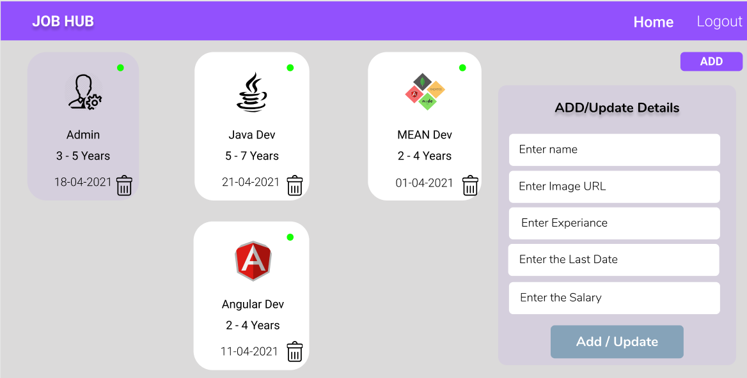
Applied Jobs:
Output Screenshot:
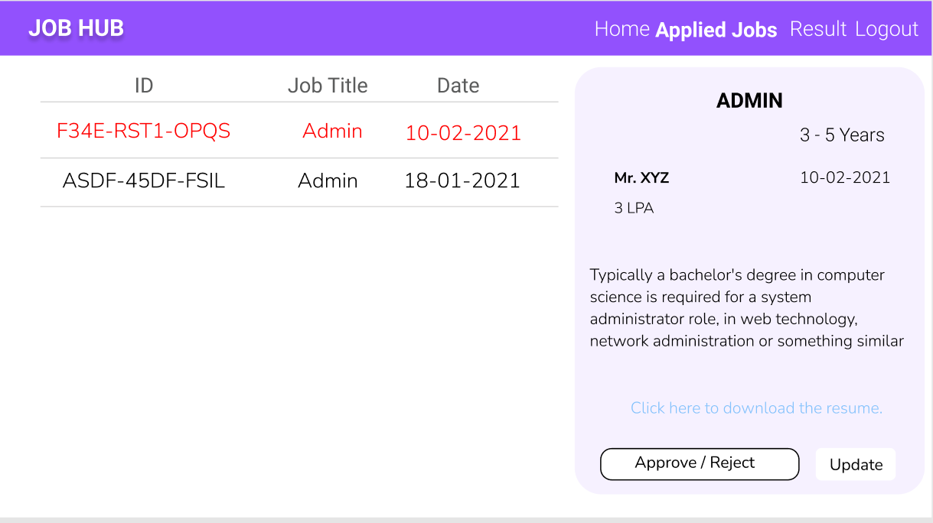

Admin:
Home:
Output Screenshot:
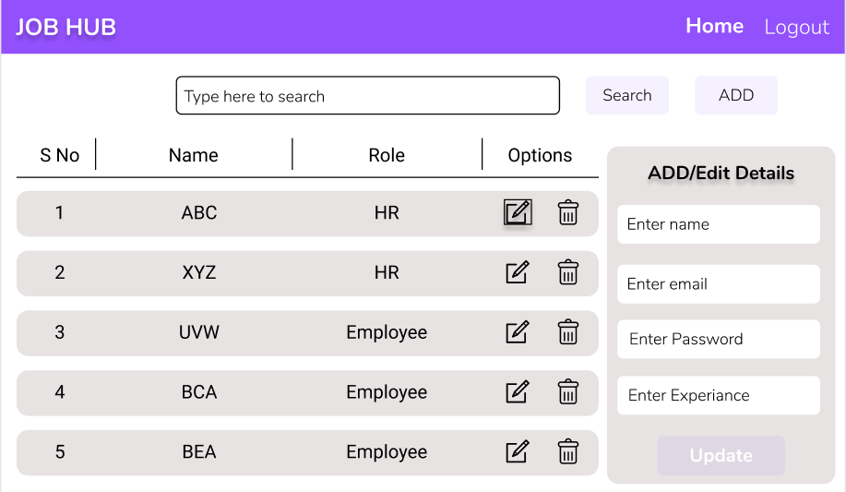

Backend:
Class and Method description:

Model Layer:

- EmployeeModel: This class stores the user type (HR or the Employee) and all user information.
  - Attributes:
    - email: String
    - password: String
    - empId: String
    - mobileNumber: String
    - department: Boolean
    - role: String
  - Methods: -
- LoginModel: This class contains the email and password of the user.
  - Attributes:
    - empid: String
    - password: String
  - Methods: -
- JobModel: This class stores the details of the Jo.
  - Attributes:
    - jobTitle: String
    - jobLocation: String
    - jobType: String
    - jobDesc: String
    - salary: String
    - : String
  - Methods: -
- AppliedJobModel: This class stores the applied jobs details.
  - Attributes:
    - jobId: String
    - employeeId: String
    - appliedDate: Date
  - Methods: -
Controller Layer:
- EmployeeController: This class controls the add/edit/update/view Employees.
  - Attributes: -
  - Methods:
    - List<EmployeModel> getEmployee(): This method helps the admin / HR to fetch all employees from the database.
    - EmployeModel getEmployeeById(String id): This method helps to retrieve a Employee from the database based on the employee id.
    - EmployeeModel editEmployee(EmployeeModel data): This method helps to edit a employee and save it to the database.
    - saveEmployee(EmployeeModel data): This method helps to add a new employee to the database.
    - deleteEmployee(String id): This method helps to delete a Employee from the database.
- LoginController: This class controls the user login.
  - Attributes: -
  - Methods:
    - checkUser(LoginModel data): This method helps the user to sign up for the application and must return true or false
- JobController: This class controls the add, edit, update, view Jobs.
  - Attributes: -
  - Methods:
    - List<JobModel> getJobs(): This method helps the HR to fetch all jobs from the database.
    - List< JobModel > getHomeJobs(): This method helps to retrieve all the jobs from the database.
    - JobModel jobEditData(String id): This method helps to retrieve a job from the database based on the jobId.
    - jobsEditSave(JobModel data): This method helps to the HR to edit a jobs and save it to the database.
    - jobSave(JobModel data): This method helps the HR to add a new job to the database.
    - jobtDelete (String id): This method helps the HR to delete a jobs from the database.
- AppliedJobController: This class helps to mapping the employees with the jobs.
  - Attributes: -
  - Methods:
    - jobMapping(String jobId, String employee Id): This method helps to mapping the job
    - List<AppliedJobModel> showJobs(String id): This method helps to view all the bobs by specific user.
    - deleteMapping(String jobId, String employee Id ): This method helps to delete a mapping between the employee and jobs applied.

